Magic Biography: Mike Pustilnik
Gary Wise
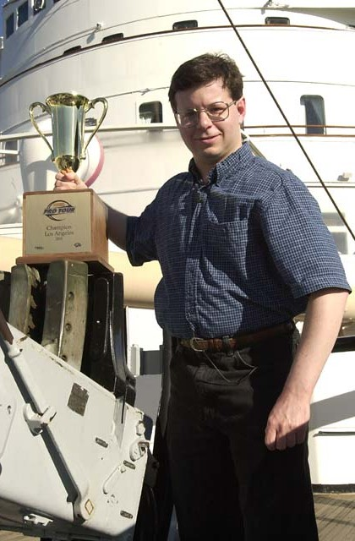
It isn't every star that leaps into greatness. Randy Buehler and Dirk Baberowski each won their first Pro Tour, and that meant that among those who had never met them, they were always stars. Every player these two met after their Pro Tour win knew them as 'Pro Tour winner,' and as a result, in most situations related to Magic, they were afforded instant respect. One might say they never had to pay their dues on Tour. Not everyone gets off so easy.
Mike Pustilnik is the epitome of the word gamer. Not content to limit himself to one game, Mikey P is a man who tries to excel in any game he tries, and a man who seemingly tries them all. He's been lurking around the Pro Tour since Hammer and Tom Guevin were duking it out in the finals. He's had his ups and downs, his bright spots and disappointments, but until this year, he'd never truly shone. This is his year.
Pustilnik is presently having one of the best years in PT history. He's won a Pro Tour and made consecutive PT Top 8s. He's made a GP Top 8 and he's leading the Player of the Year Race, but his trip to the top hasn't been all sunshine and lollipops. Mike has taken his bumps and survived the darker times to emerge from the shadows and now he bathes in the light of his success. What follows is his story of perseverance.

"Mike is one of those players who can clearly be identified as rogue, in both Limited and Constructed. He builds decks his own way, and is able to play them well, even if most other players cannot." -Alex Shvartsman
Born to a now retired math professor father and a now retired investigator for the Brooklyn District Attorney thirty-five years ago, Mike Pustilnik loved games from the start. Introduced to Monopoly, Chess and Risk by his elder cousin Mark while very young, Mike eventually found himself seeking greater competition and found himself playing tournament Chess, Bridge, Shogi, Backgammon and various war games including Titan, Panzergruppe Guderian and Advanced Third Reich.
In 1994, Mike's roommate Michelle Goldstein, in need of an opponent, taught the Chemistry PhD how to play Magic. "At the time, I didn't have any cards of my own, so I played her WG deck against her UB deck. Although neither deck was optimal, the UB was definitely better, and Michelle (who likes winning) insisted on playing UB every time." Frustrated by his deck's inability to deal with Michelle's Hypnotic Specters, Mike took measures to end their dominance.
Buying a few packs of Revised, Mike built himself a UG deck that didn't fare much better against Michelle's now RB deck, with cards like Living Lands not holding up too well to Fireball and the like. Finally, he decided to invest some money in the game and bought the cards he needed to create what he felt was an efficient WB deck:
11 Plains
11 Swamps
2 Scrubland
1 Sol Ring
1 Demonic Tutor
3 Savannah Lions
4 Serra Angels
4 Erg Raiders
4 Hypnotic Specters
4 Sengir Vampires
3 Disenchant
4 Swords to Plowshares
4 Terror
4 Drain Life
Within the next couple of months, Mike would add two more Scrublands, a Savannah Lion and a Mind Twist to the mix and after a friend suggested the addition of Mishra's Factory and Order of the Ebon Hand, his masterpiece was complete. Soon, Mike was winning his share of tournaments.
In the spring of 1996, Mike got what would be one of the most important phone calls of his life. Through winning sanctioned tournaments and the like, Mike had boosted his rating to an elite level, prompting Wizards of the Coast to call and inform him that he'd qualified for the second Pro Tour, to be held in Los Angeles. More out of curiosity than anything else, Mike attended LA, but by his own admission he wasn't fully prepared for the tournament, and he finished 65th.
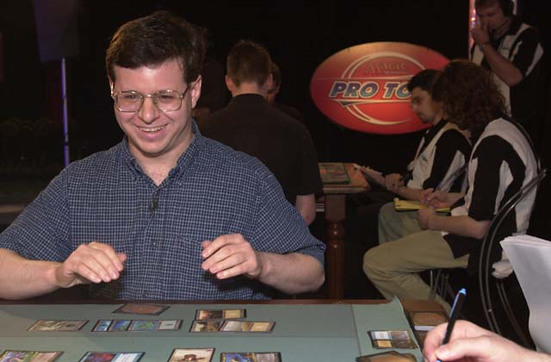
Mike tried but failed to qualify for the Tour's next two stops before establishing a pattern for himself. Going back to his GU roots (as he would do often later on) Mike designed a deck he called Web Browser, a creature based control deck, and he won his first PTQ in trying to qualify for Dallas where he would go on to finish in the money at 60th place.
Failing to qualify for the next two PTs, Mike finally managed to secure a spot in PTNY 1997 thanks to a Top 8 finish at GP Washington. This would be the launching pad for Mike's first great success. Going 4-1-1 on Day 1, Mike proceed to go 3-0 to start Day 2, defeating PT Champions Paul McCabe and Shawn 'Hammer' Regnier, as well as junior PT Champion Justin Schneider in that first draft. He followed this up with a 2-1 second draft, securing him a spot in his first Top 8. Unfortunately, he didn't get to savor it for very long, with a poor final draft leading to a quarterfinal defeat at the hands of Czech Ivan Stanoev. Mike wouldn't see Day 3 again for over three years.
The 1997-98 season was a frustrating one for Mike. Qualified for the four PTs following his New York success, Dr. P was unable to take advantage. Four times he went to Tours and all four times he failed to crack the top 100, with his best finish being 107th in Chicago '97. Failing to qualify for World Championships for the second year in a row, Mike's problems continued into the next season, where he finished 156th in Chicago, but finally, his fortunes began to turn around. It would be the last time he would fail to make Day 2.
Making the trip to PT Rome, Mike finished a respectable 49th place playing a 4-color Tradewind deck of his own design. While his finish didn't qualify him for LA, it gave him a much needed confidence boost after a rough year and a half on Tour. Beating Brock Parker, Matt Linde and Iron Peter Ripley in a PTQ Top 8, Mike qualified for that year's PT New York, where he had his best finish since his Top 8 finish, coming 13th in a Urza's Block environment dominated by Academy decks with his heavily metagamed BR deck. Not only did this qualify Mike for the next Pro Tour stop, but also it qualified him for his first World Championships.
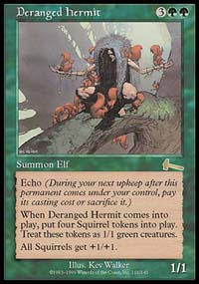
Worlds was a disappointing event for Mike, who came 146th, but with its end came the end of Mike's failures on Tour. The 1999-2000 season was to be a very solid season for the New Yorker, starting with a money finish in London, a precursor to his first premier level event victory. Mike went back to his GU roots and created a deck, Squirrel Prison, that would go on to dominate Urza Block Constructed and piloted it to victory at GP Memphis. The win would provide the only high level money Mike would make during a frustrating six months during which he made Day 2 at each of Chicago, LA and NY only to finish out of the money in all three events.
Mike's next check came at Worlds in Belgium, where he finished 52nd, but Mike's resolve had been increased earlier in the year. With the announcement that the Masters Series would be introduced, Mike decided to take a shot at full time Magic and began a stretch of six months that would see him make money at six different Grand Prix, including Top 8 finishes at Porto and Valencia. Even that though was a mere foreshadowing of what he would accomplish in Chicago and LA.
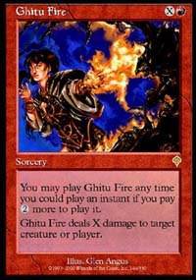
Preparing for Chicago with Alex Shvartsman and anyone who was willing at his most frequent Magic hangout, Neutral Ground New York, Mike came to understand that among the most popular T2 archetypes, Fires was the one he liked most. Tuning his deck in the days leading up to the tournament, Mike's version included one card that almost everyone else overlooked: Ghitu Fire. Instead of the more limiting Urza's Rage, Rhystic Lightning, Assault/Battery and Scorching Lava, Mike chose the X spell that would allow him to cast it as an instant.
The results were staggering. Starting the tourney 6-0, Mike was in contention all the way. Playing German Markus Bell in the final round of the Swiss, Mike needed the full three points a win would provide in order to advance to his first Day 3 in over three years. One of the Tour's longest standing and most liked personalities by this time, everyone knew the moment he won the match, with a loud cheer going up from the Feature Match area upon the realization he'd made the Top 8.

"I really wish I could get him to test online, but I guess he likes the game too much. When I'm off complaining about a format, he's busy enjoying the game and every other game from Chess, Backgammon and Go to Titan and Advanced Third Reich. What's more, I can't seem to beat him in any of them." -Zvi Mowshowitz
Like his first Top 8 finish, Mike lost his quarterfinal match, finishing in sixth this time around, but now there would be no looking back. With relatively little preparation for Los Angeles, Mikey went in knowing the cards and his preferences. A solid finish was a reasonable expectation as, after all, he'd just come off the second best PT performance of his career and was consistently doing well on the GP circuit, but what happened was beyond his wildest dreams.
Mikey started off well enough, going 2-0 before an improbable draw with Jakub Slemr. With both players 2-0-1 going into the second draft, it wasn't a huge surprise that they faced each other again, and this time Mike got the full three points. After another win, Mike lost the sixth round to Switzerland's Christian Fehr. Then, in more than resilient fashion, Mike went on an unbelievable streak. Winning his final match of Day 1, Mikey followed that up with an amazing 7-0 record against the Pro Tour's best. In the Top 8, Mike got his ninth straight win against American Lawrence Creech and number 10 against Ben Klauser, advancing to the final against the Magic's other hot story, Kamiel Cornelisson.
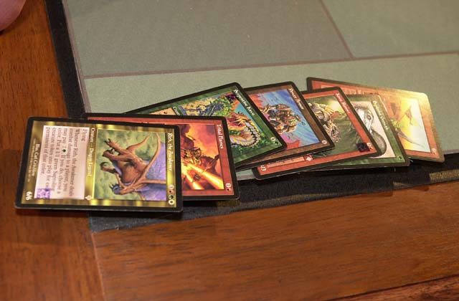
Like Mike, Cornelisson had also made the Top 8 in Chicago, and twice in a row he'd dispatched Jon Finkel en route to the finals. The talk surrounding the final all seemed to concern Kamiel and whether the next Finkel had arrived, but in the ruckus, Mike was all but forgotten. Splitting the first four games, the two players both seemed to be having a great time on stage. In the final duel, Kamiel had established parity and had one card in hand when Mike cast Ravenous Rats. Kamiel visibly slumped as he was forced to discard Rith, the Awakener, a card that Mike would not have been able to deal with. Amidst loud cheers from the audience, Mike's face lit up. A few turns later, he'd won his Pro Tour.
One problem PT winners often face is a way of keeping themselves interested once all of their goals have been reached. Not Pustilnik. Mere weeks later, Mike was in the Top 8 of GP Valencia, adding another three points to his already impressive Player of the Year run. Strangely, he decided to skip GP Boston though. Why miss the closest GP to home of the year? Simple. Mike Pustilnik is a gamer, and while Magic is now his profession, it doesn't stand in the way of the fact that Mike just loves to compete. That same weekend, The Titan National Championships were being help in Charlottesville, Virginia and Mike felt it was an opportunity he couldn't miss. It was a good decision. He won the tournament.
Essentially, Mike's recent run is an example of good things happening to those who wait. Mike is not only liked, but also respected for his good nature throughout the Magic World. His writing contributions, love of games and friendly demeanor make him impossible to not appreciate. With everyone so pleased at his recent success, only one question lingers: will he be able to keep putting up these results? No one knows for sure, but he'll be having fun regardless. He's playing a game.

